Update on Pharmacoeconomics in the Irish Healthcare Setting
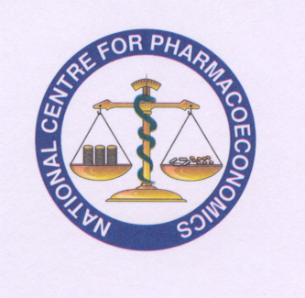
Date: 23rd & 24th March 2015
Venue: Trinity Centre for Health Sciences

DAY ONE

Morning Session

8.30AM Course Registration & Refreshments

9.15 - 10AM Introduction to Pharmacoeconomics M. Barry

10.00 - 10.45AM HTA: The industry perspective C. O’Regan
10.45 – 11.30AM HTA: The decision maker perspective S. Flanagan

11.30 – 12.00AM Question and answer session

Michael Barry, Chris O’Regan, Shaun Flanagan, Roisín Adams, Brian Murphy

12.00 - 12.45PM Cost Effectiveness within a decision making framework C. Walsh

Afternoon Session

2.00 - 2.45PM Measuring effectiveness A. O’Leary

2.45 - 3.30PM Time to Event Analysis L. McCullagh

3.45 - 4.15PM Costing Health C. Usher

4.15 - 4.45PM Preferences in HTA R. Adams

DAY TWO

Morning Session

9.00 - 9.45AM HTA for Cancer (NCCP perspective) P. Heckmann

9.45 - 10.15AM Measuring Uncertainty in
Economic Evaluation S. Schmitz

10.45 – 11.30AM A Multiple Criteria Decision Analysis Approach to HTA S. O’Meachair

11.30 – 12.15AM Combining Evidence for Economic S. Schmitz Evaluations

12.15 - 12.45PM Recent pharmaceutical cost containment measures and effects on state-funded drug expenditure in the Republic of Ireland S. Spillane

Afternoon Session

1.30 - 2.30PM Workshops:
1. Submitting to the NCPE – what do you need to know?
2. Decision making – separating facts, values and all else.

Outcomes Research:
2.30 - 3.30PM Registries in Ireland – the way forward in outcome measurement (Hepatitis C and Cystic Fibrosis examples)
A. O’Leary & A. Jackson

3.45 - 4.15PM Incorporating the patient perspective in HTA C. Walsh

4.15 - 4.45PM Challenges ahead for all R. Adams

4.45PM Closing Remarks

